
Cloud Computing Lab

Submitted to:
Engr. Muhammad Shoaib

Submitted by:
Hania Akbar

Reg no:
2023-BSE-026

Section:
A

Lab 11 – GH CLI Codespaces + AWS + Terraform: Variables, Collections, Sensitivity & EC2 Provisioning

Task 0 Lab Setup (Codespace & GH CLI)
All actions below should be executed inside the Codespace shell.
Create Codespace & connect:

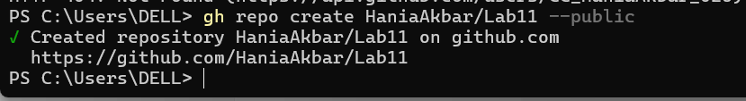

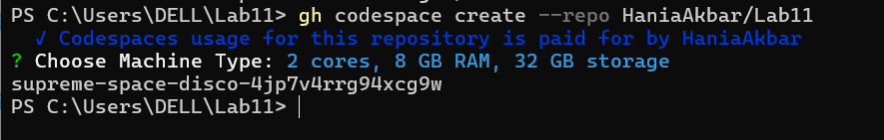

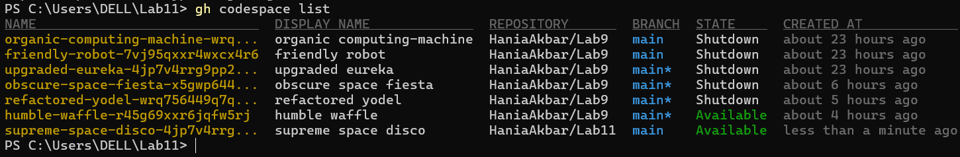

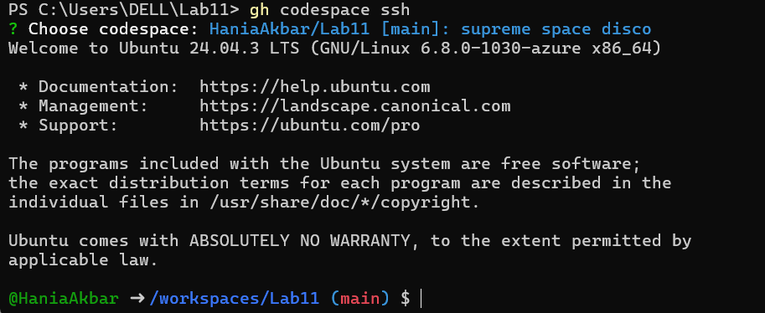

Task 1 — Provider & Basic variable (variable precedence)
- In Codespace create main.tf:

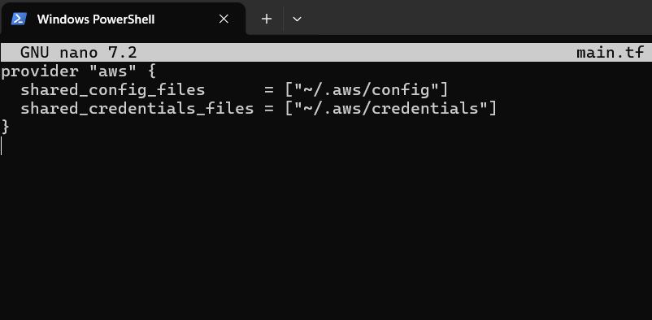

- Initialize:

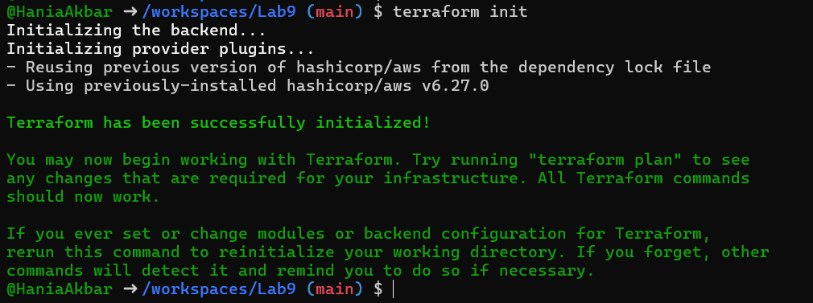
- Define a variable and output:

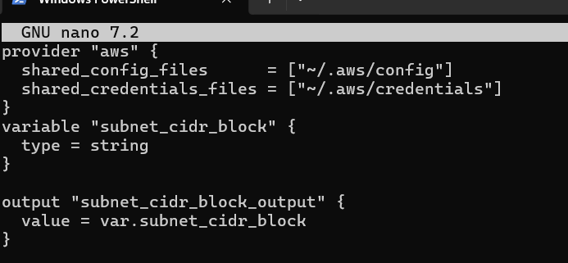
- Run apply (first time without defaults):

- Add a default to the variable:

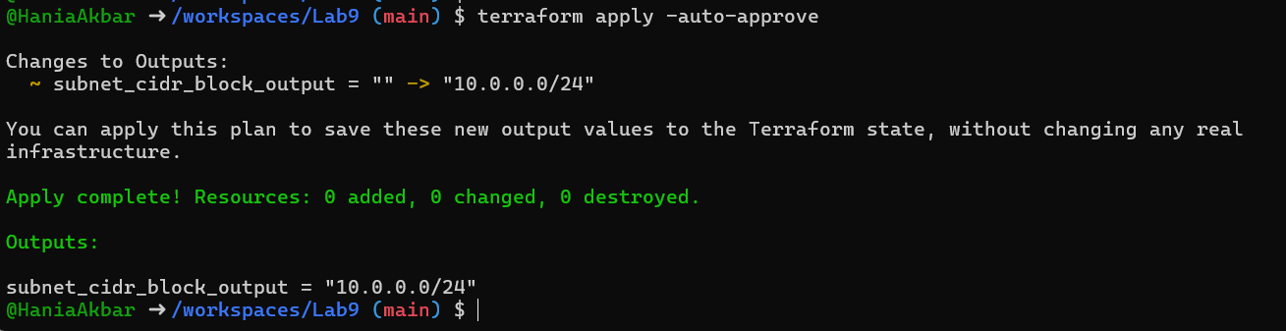

- Export environment variable in Codespace shell:

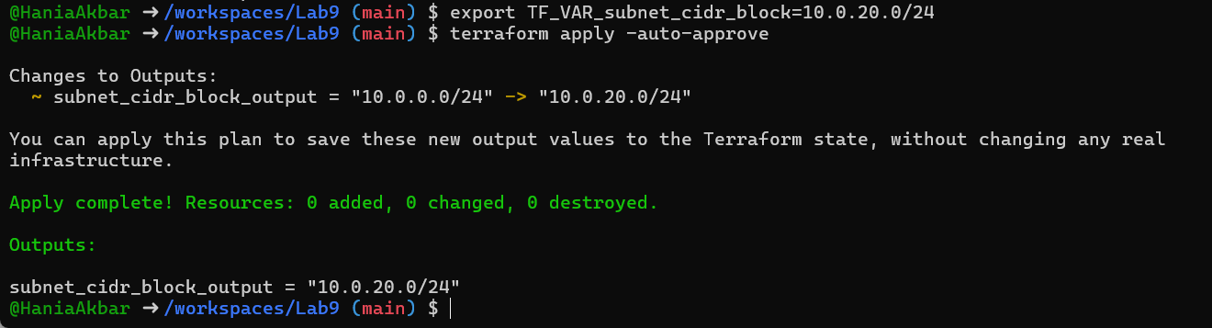

- Create terraform.tfvars overriding values:

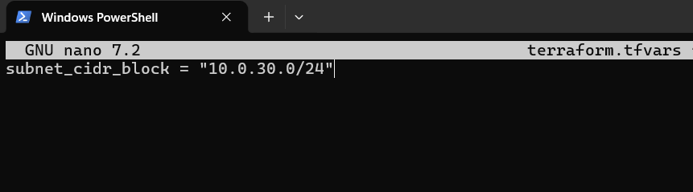

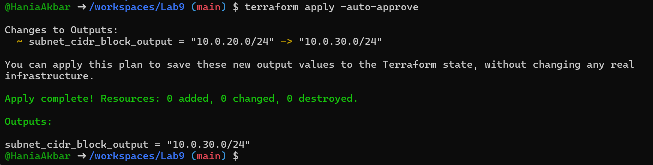

- Override with -var:

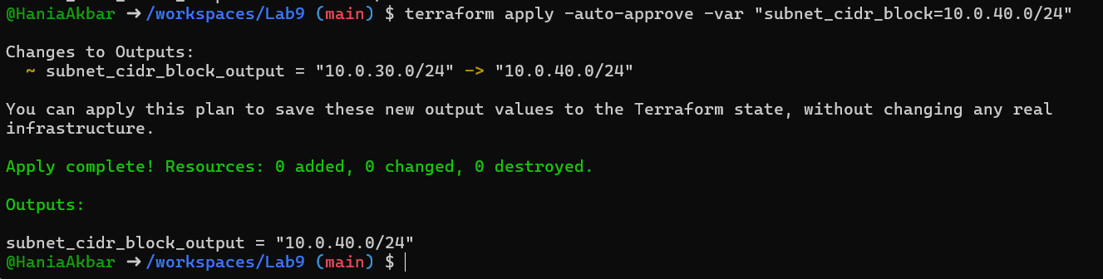

- Show and unset env var:

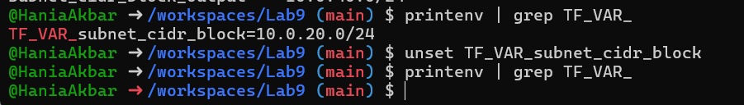

Task 2 — Variable validation & sensitive / ephemeral variables
- Replace subnet_cidr_block variable with this (validation included):

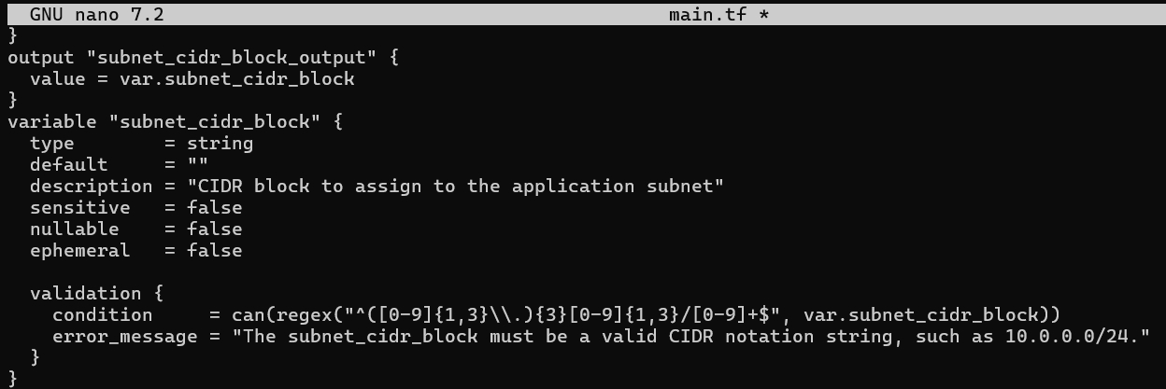

Step 2: Test validation failure

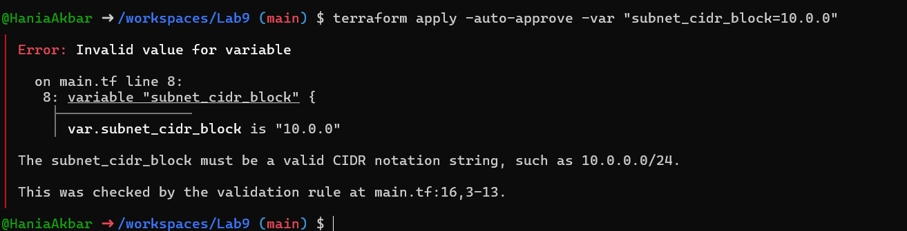

Step 3: Create sensitive variable api_session_token and output
Append to main.tf:

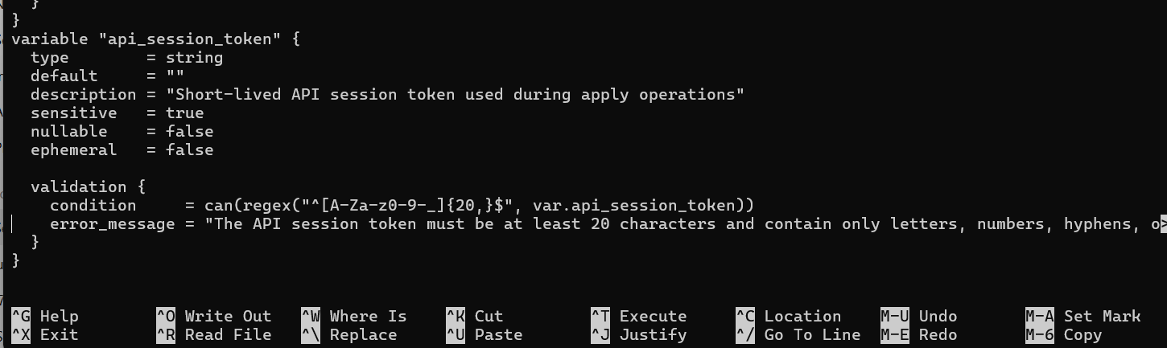
- Run with -var to observe sensitive output behavior:

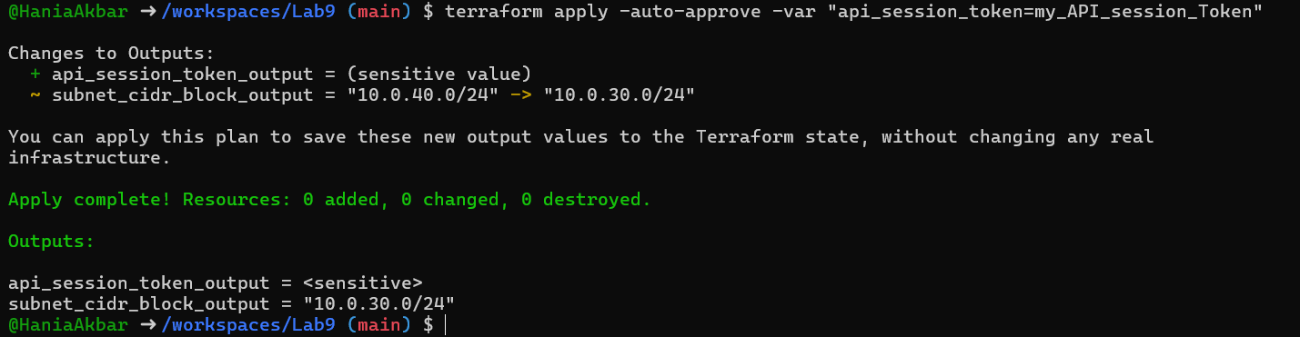

- Check terraform.state for the sensitive output:

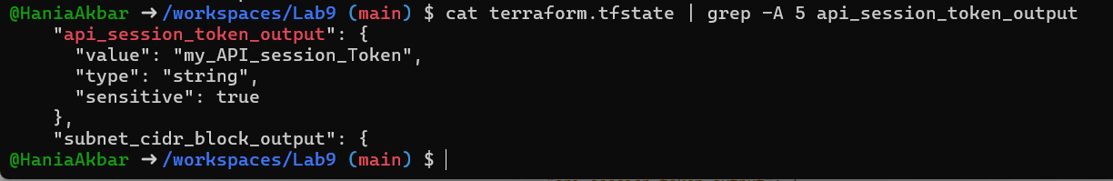
- Make variable ephemeral to hide from state:

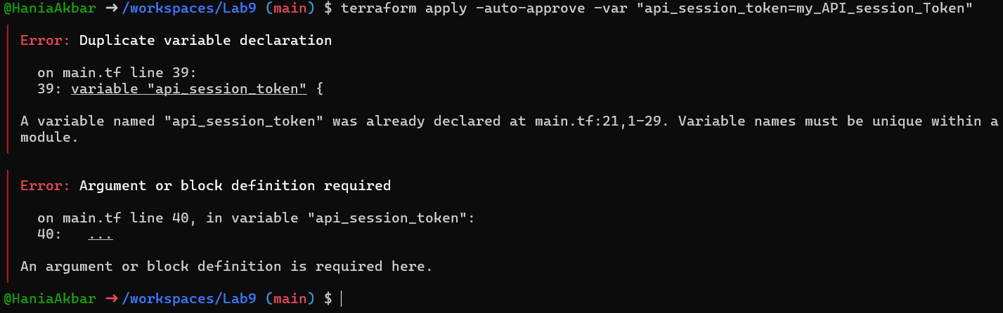
- Set default to test local default:

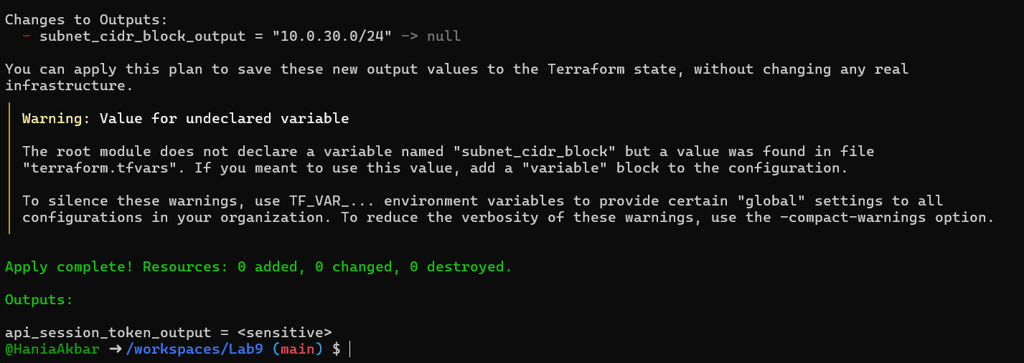

Task 3 — Project-level variables, locals, and outputs
- Add variables to main.tf:

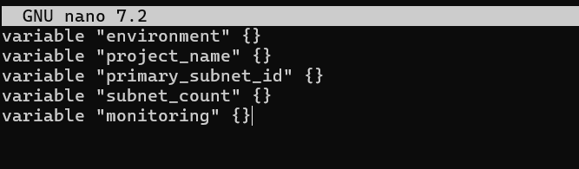
- Populate terraform.tfvars after discovering actual subnet id for availability zone me-central-1a:

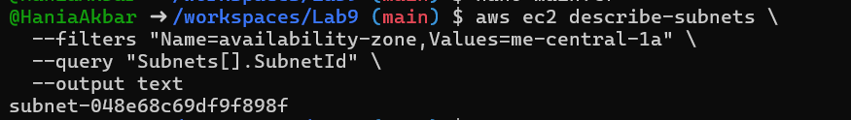

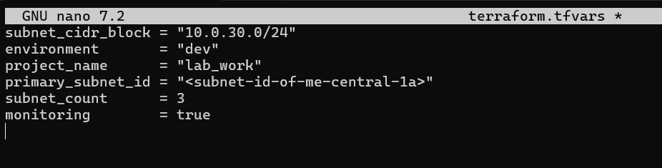
- Create locals.tf with:

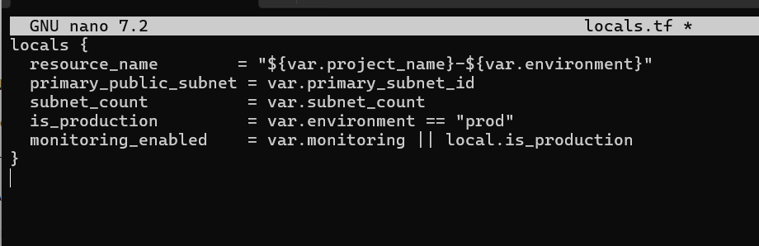
- Add outputs to main.tf:

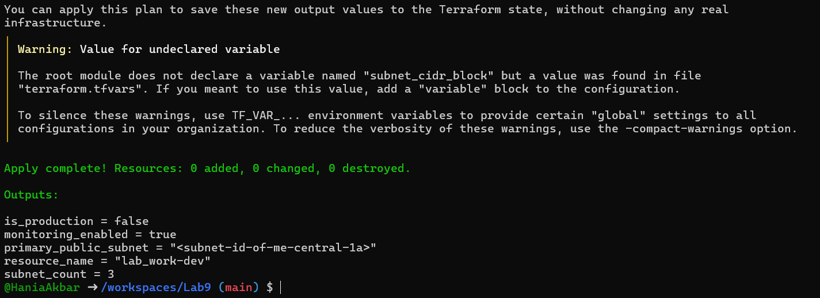

Task 4 — Maps and Objects
- Map variable in main.tf:

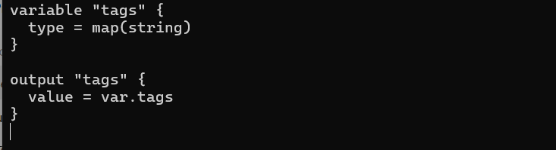

- In terraform.tfvars:

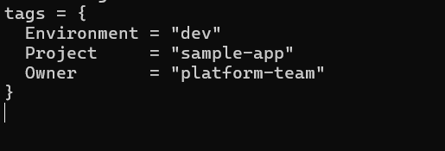
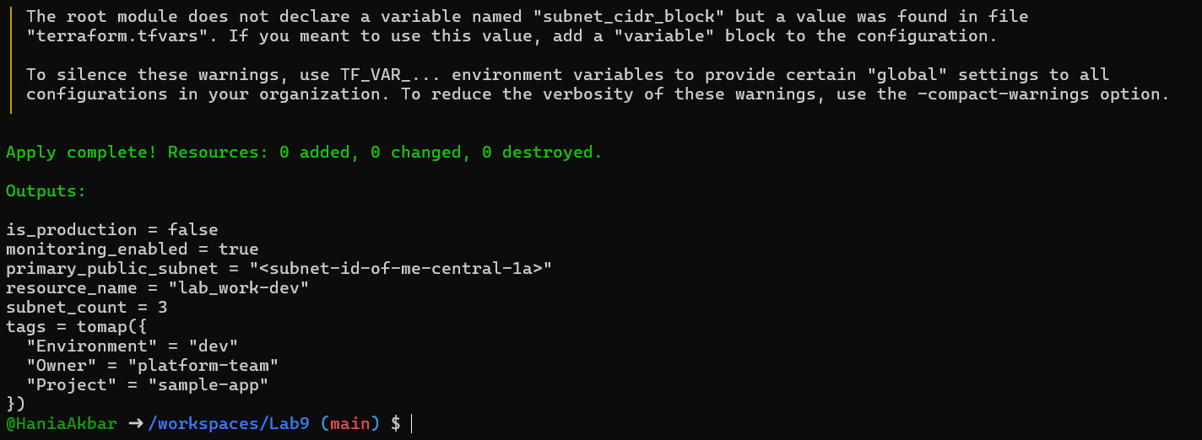
- Define object variable:

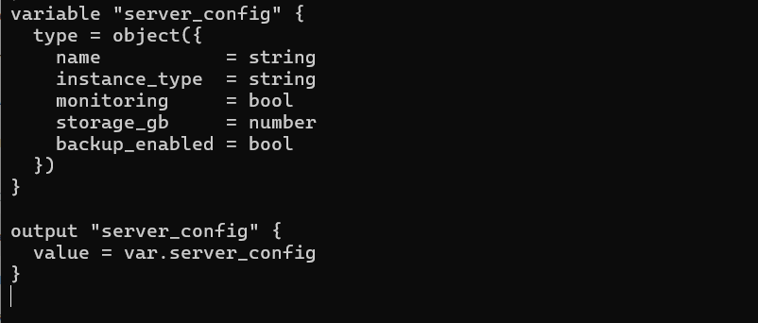
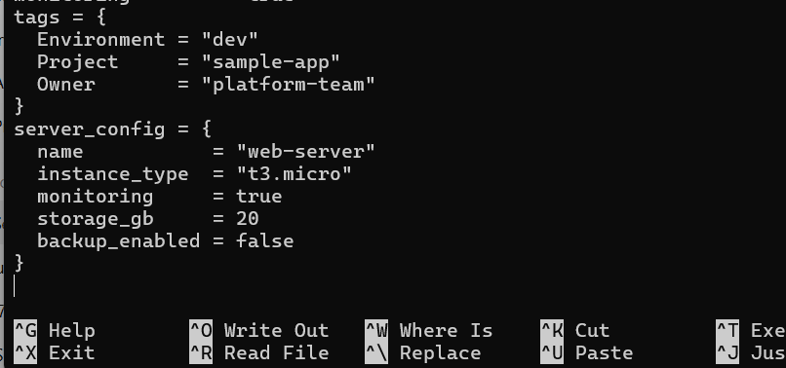

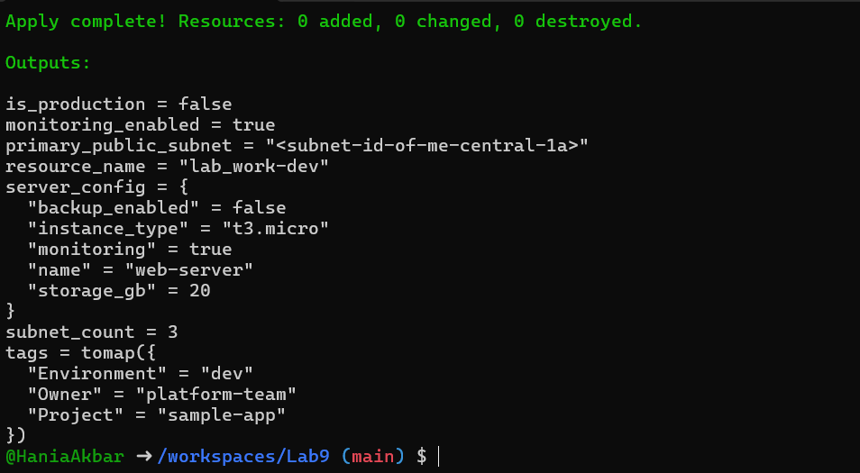

Task 5 — Collections: list, tuple, set & mutation via locals
In this task you will define collection variables (list, tuple, set), observe their behavior, then perform mutations via locals and compare results.

- In main.tf define:
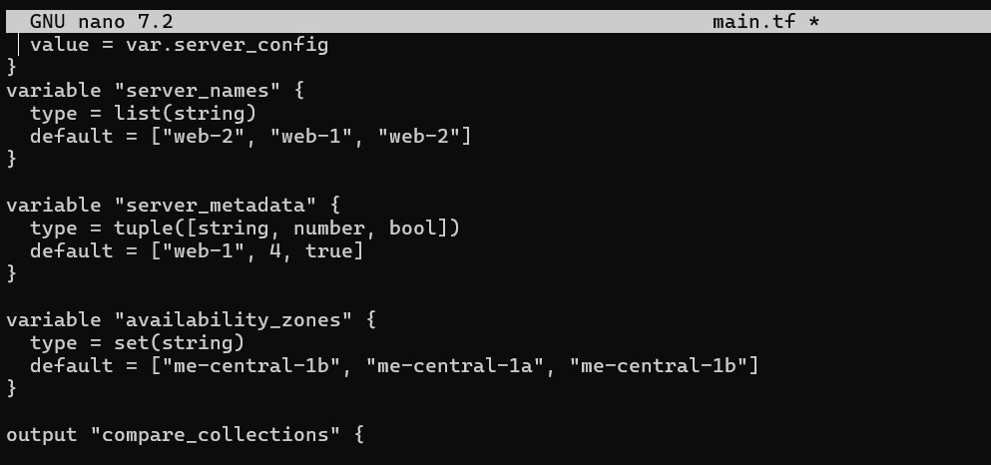

- Run:
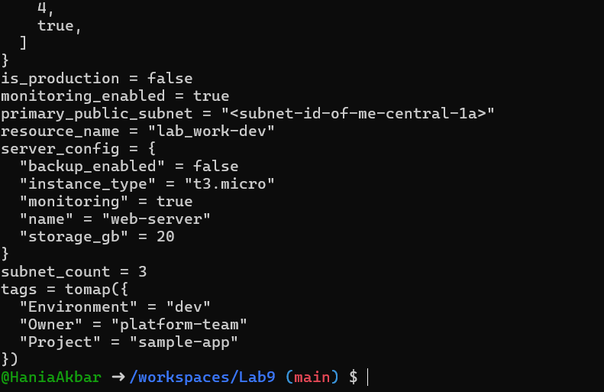

- In locals.tf add mutations: Create or edit locals.tf and add the following locals to demonstrate mutation behavior. Note: tuples are immutable in Terraform's type system, but many operations convert them to lists for evaluation.
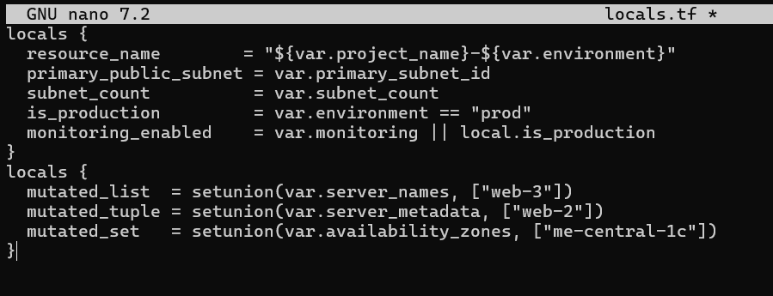

- Add comparison output in main.tf:
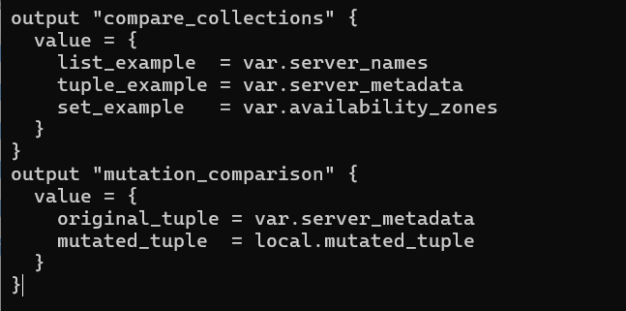

Run:
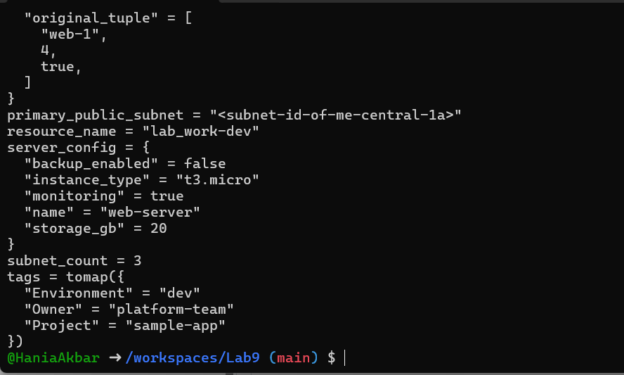

Task 6 — Null, any type & dynamic values
- Null variable:

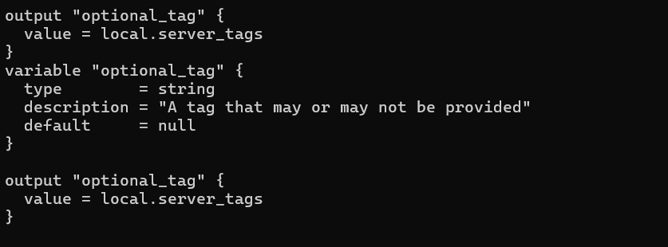

- Merge tags in locals.tf:
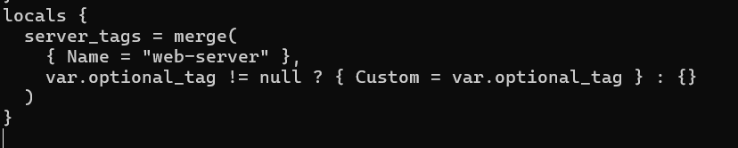
- Output:
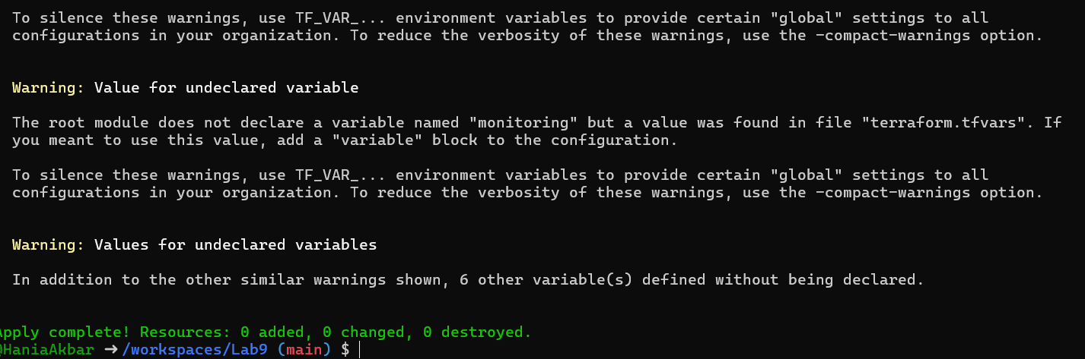

Run:

- Add in terraform.tfvars:

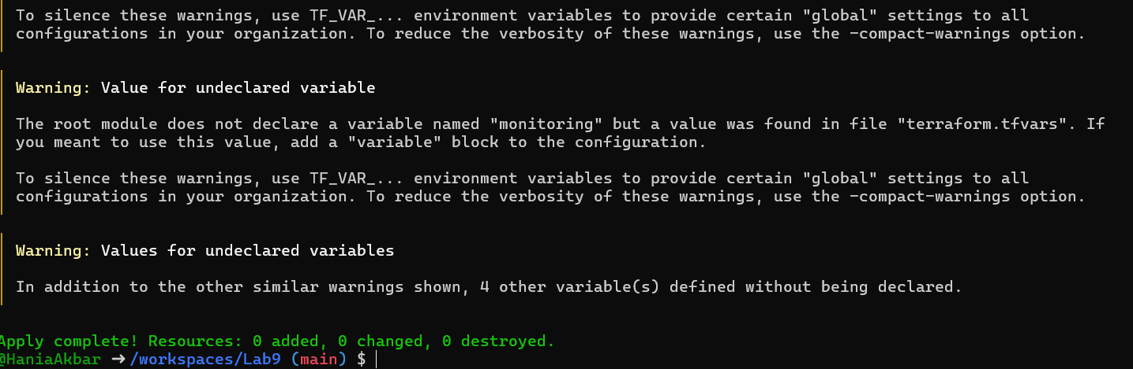

- Now test the dynamic (any) variable with different types. For each change, update terraform.tfvars with the specified value and run terraform apply -auto-approve, then capture the output.
a) String

- Run:
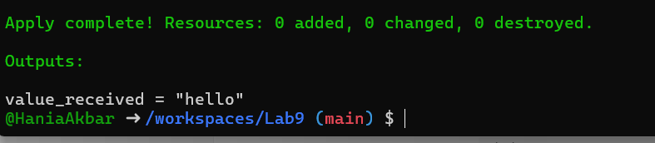

b) Number
- Change terraform.tfvars:
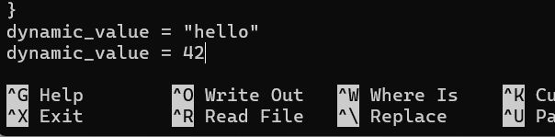

- Run:
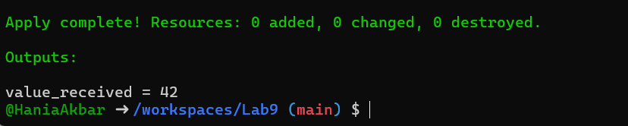

c) List
- Change terraform.tfvars:
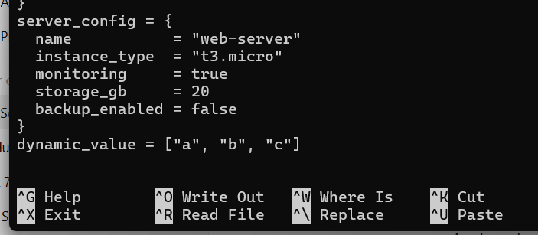

- Run:
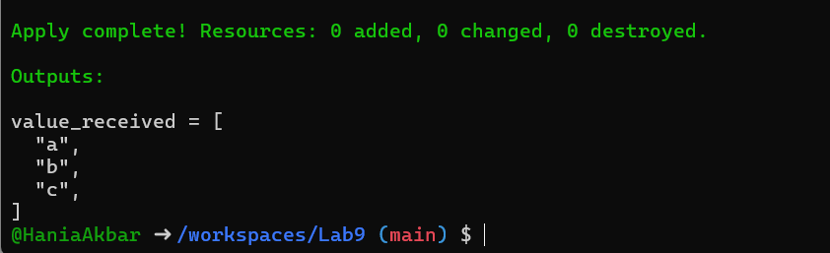

d) Map / Object
- Change terraform.tfvars:
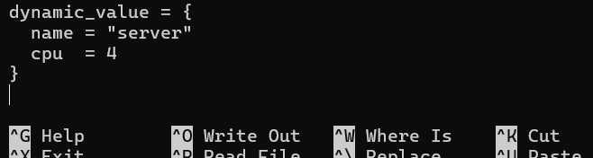

- Run:
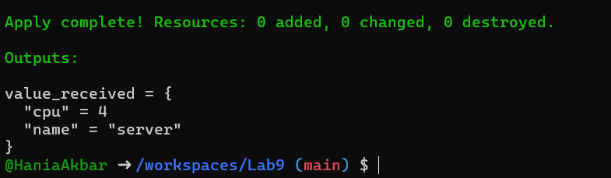

e) Null
- Change terraform.tfvars:
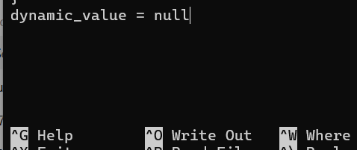

- Run:

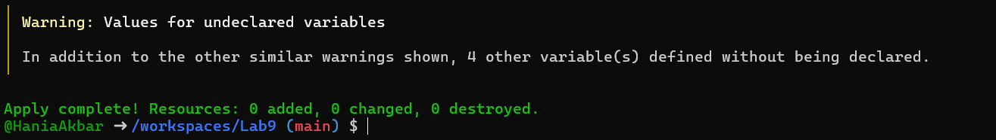

Task 7 — Git ignore
Create .gitignore:

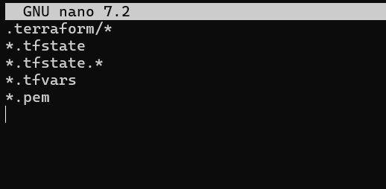4

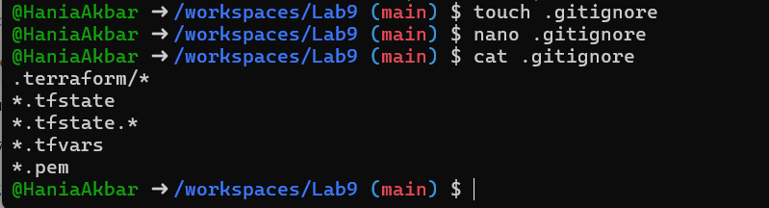

Task 8 — Clean-up then build real infra (VPC, Subnet, IGW, routing, default route table)
In this task you will clean previous example values and build a simple VPC + Subnet, attach an Internet Gateway, and configure routing (first with a custom route table and association, then switch to the default route table).
Perform all commands inside your Codespace shell.
- Clean previous files

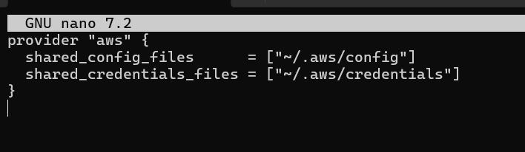
- Define variables in main.tf Add these variable declarations to main.tf (below the provider block):
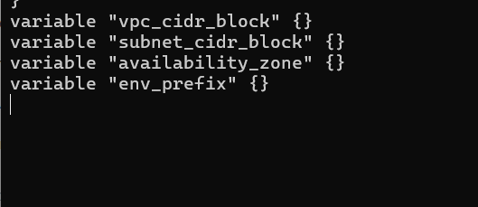

- Create VPC in main.tf Add the VPC resource to main.tf:
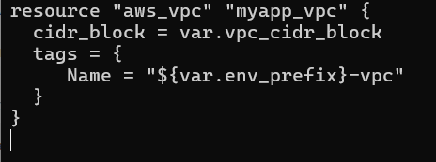

- Create Subnet in the VPC Add the subnet resource to main.tf:

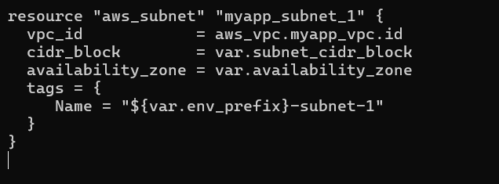

- Populate terraform.tfvars In terraform.tfvars add:
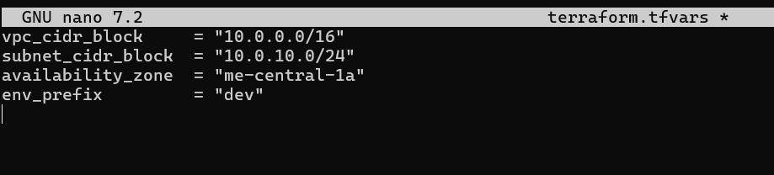

- Apply to create VPC and Subnet Initialize (if needed) and apply:
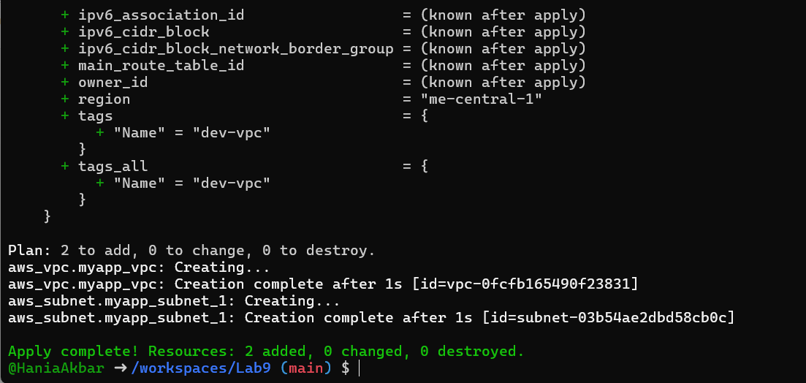

- Create Internet Gateway and Route Table (custom) Add the Internet Gateway and a custom Route Table to main.tf:
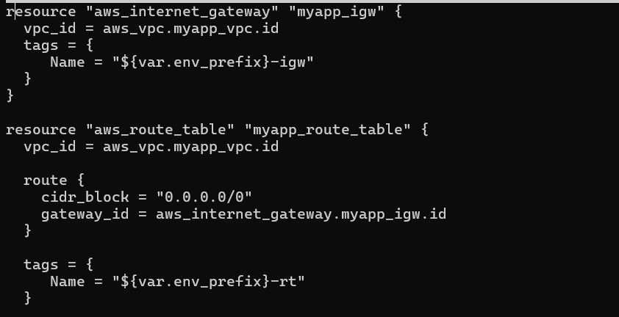
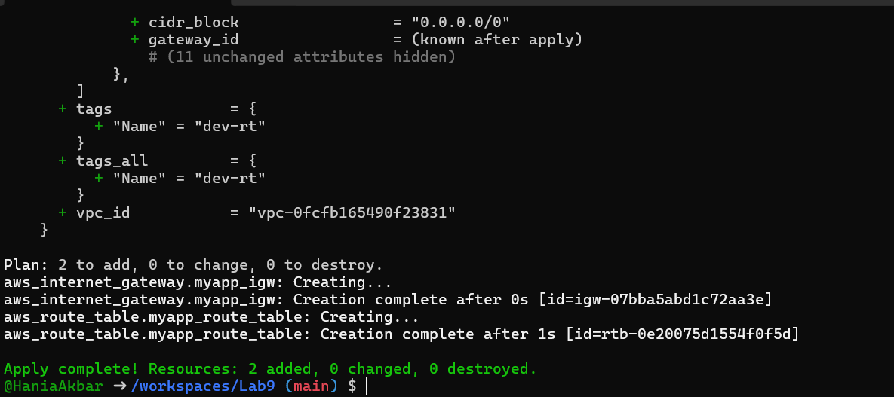
- Associate the Route Table with the Subnet Add the association resource to main.tf:
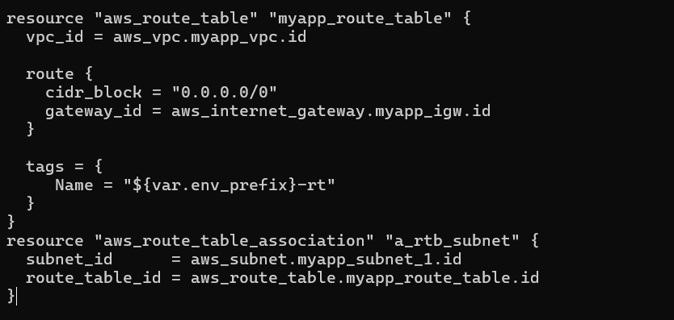

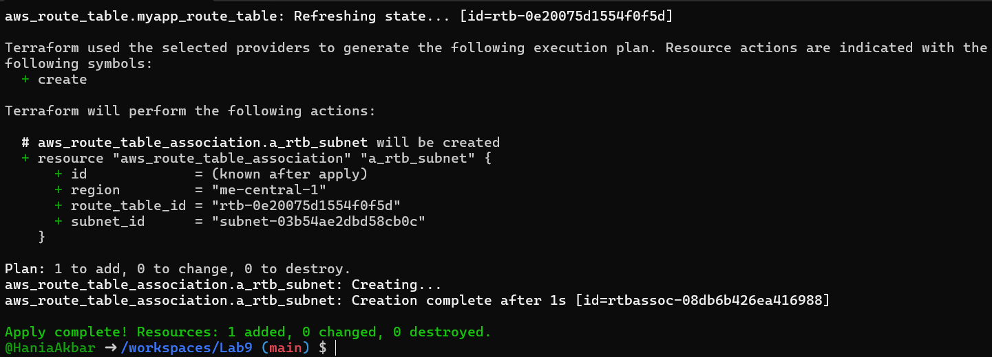

- Switch to default route table (use VPC default route table) Now remove (or comment out) the custom route table and association resources from main.tf:
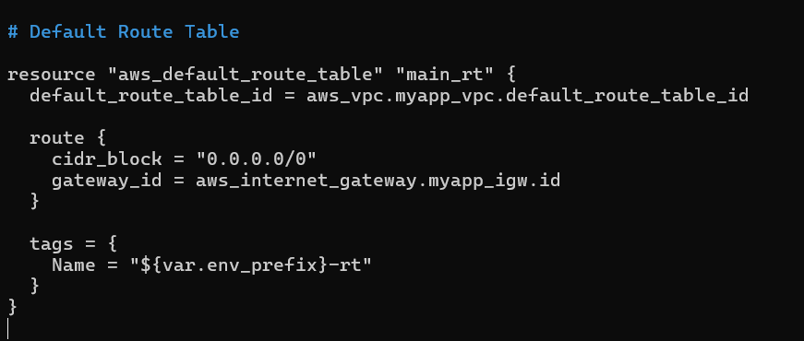

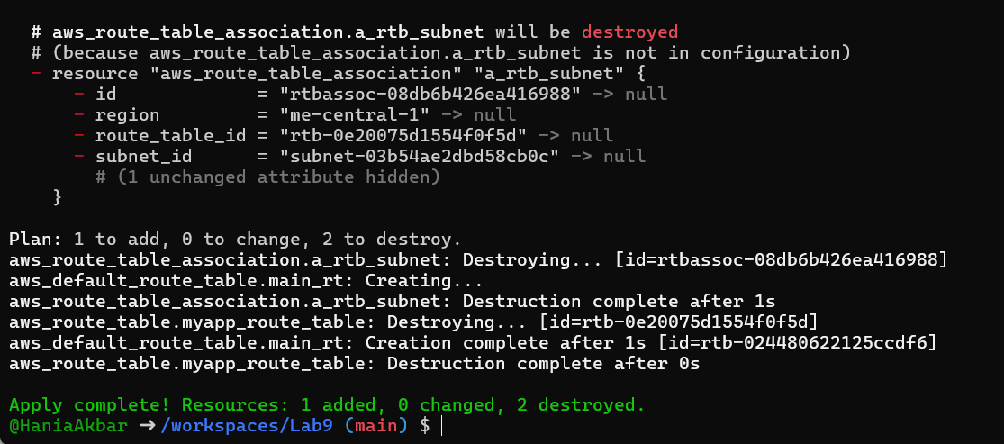

Task 9 — Security Group, Key Pair, EC2 Instance, user_data & nginx
This task walks you through creating a security group, creating an EC2 key pair, launching an EC2 instance, verifying SSH access, and installing nginx via user_data (inline and from a script). Perform all commands from your Codespace shell.
- Add variables to main.tf Add these variables to your main.tf:

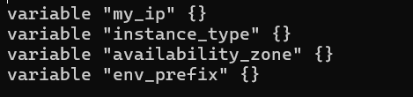
- Get your public IP and set terraform.tfvars From the Codespace shell:

Copy the IP and add to terraform.tfvars:
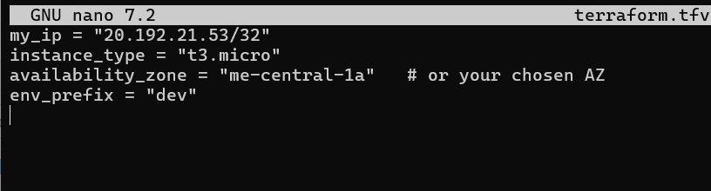
- Create the Security Group (main.tf) Add this resource to main.tf:
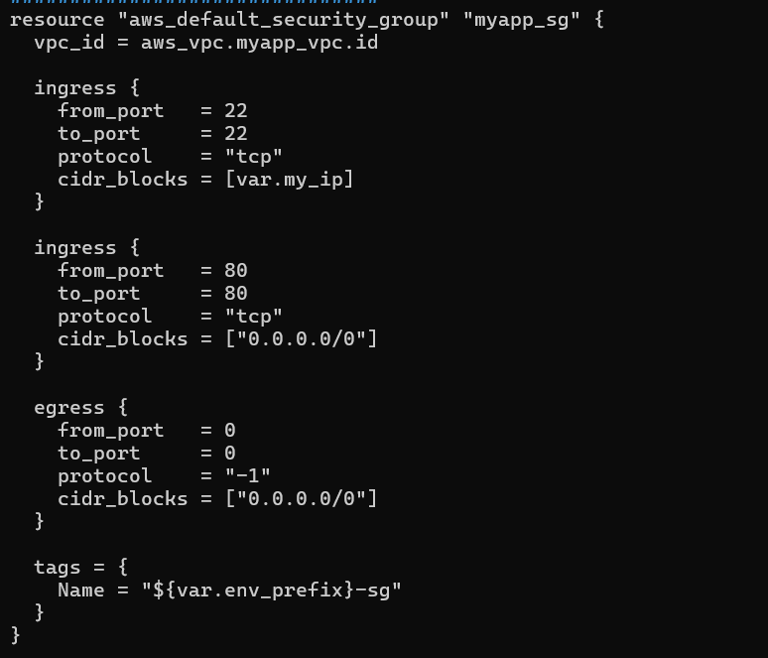

Run apply:
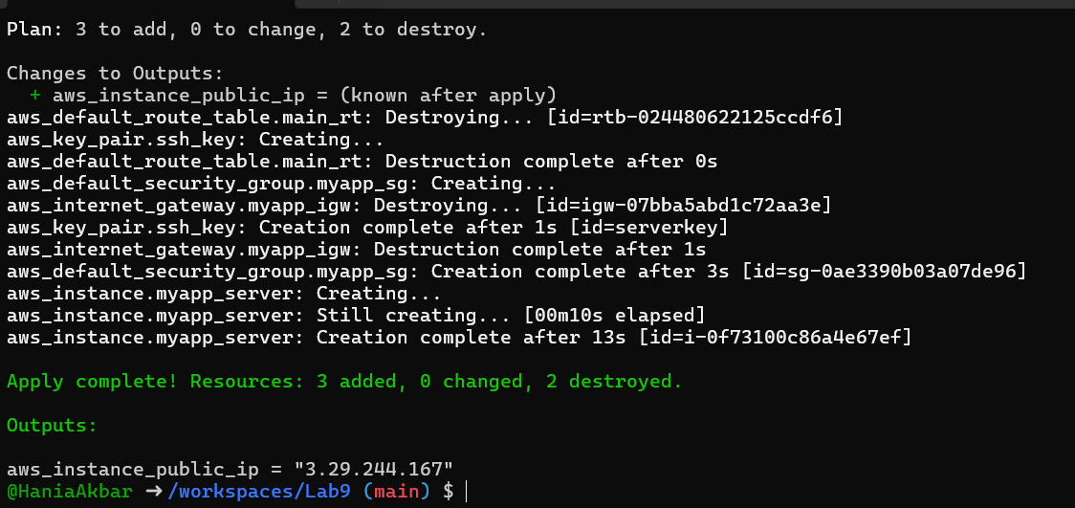

- Create an AWS key pair and save locally Create a key pair and store the private key in your Codespace. Do NOT commit the .pem file.
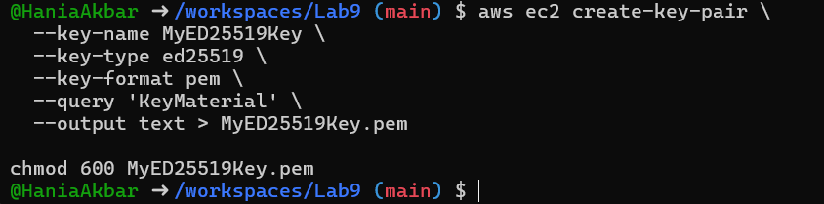

- Add EC2 instance resource (initial) Add the instance resource to main.tf (initially using the created key name):
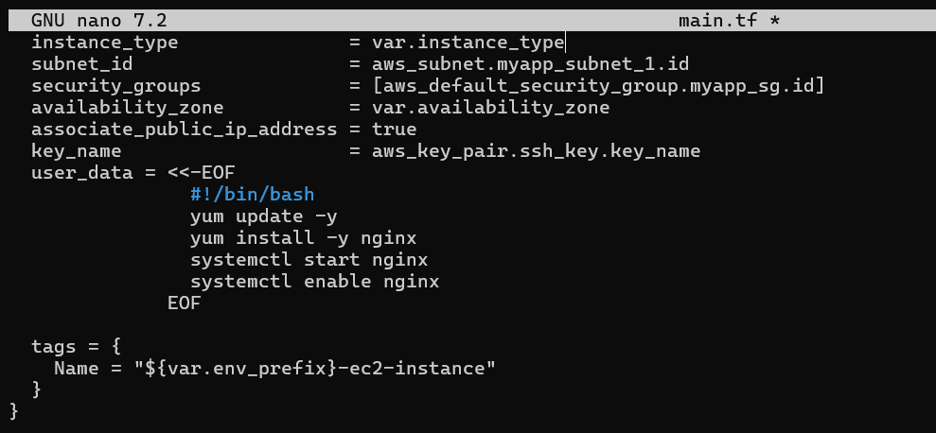

Run:

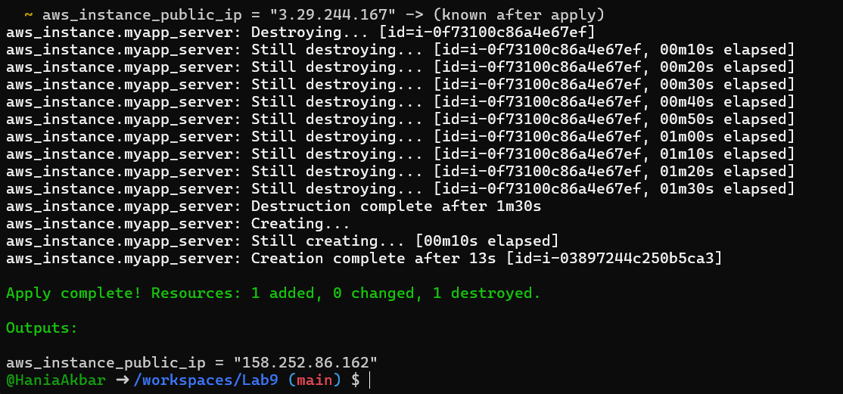

- SSH into the instance (using MyED25519Key) From the Codespace:

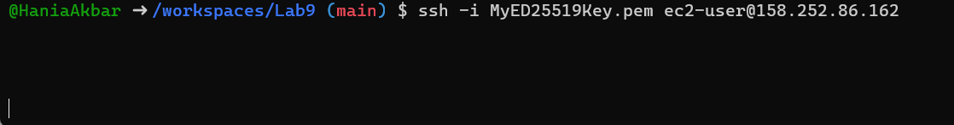

- Generate a local SSH keypair and register it in AWS via Terraform On your Codespace, generate an SSH key pair (accept defaults or specify path):
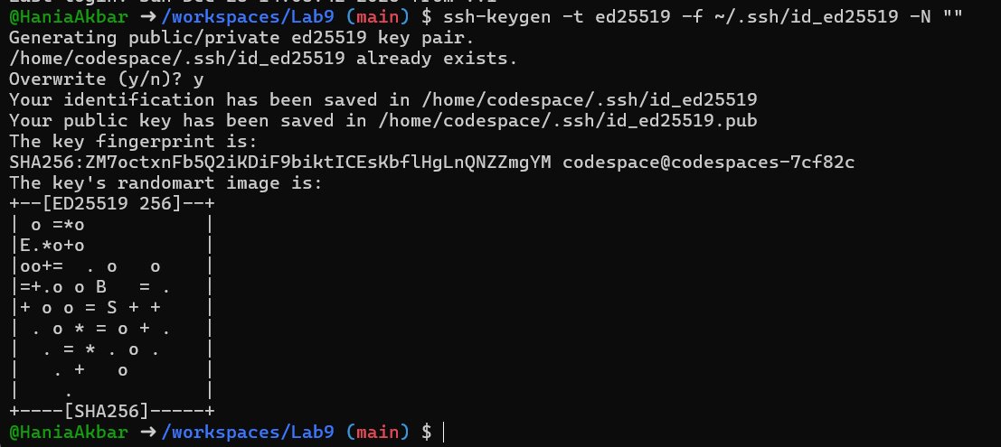

Update the EC2 resource to use the Terraform-managed key:

Run:

- SSH using the newly registered key Now SSH with your generated private key (the default ssh client will pick up ~/.ssh/id_ed25519):


- Install nginx via inline user_data Modify the aws_instance resource to include inline user_data:

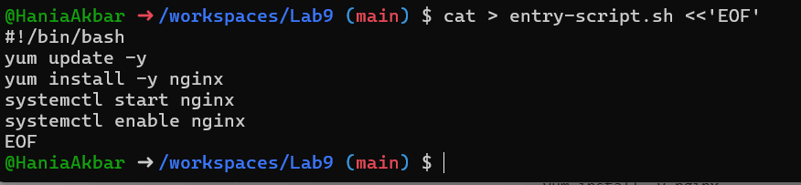

Cleanup
- Destroy all resources:

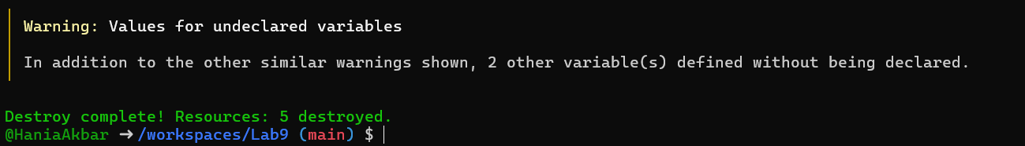

- Verify state files:
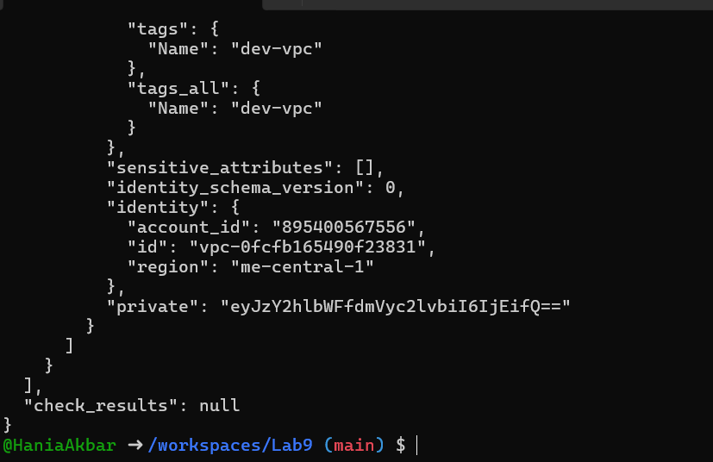

- Ensure no sensitive files are committed. If any private keys or credentials were accidentally committed — rotate them immediately.
